How to Reset Opera Password with Opera Password Recovery
Tips: Below are the steps to recover a password to protected web sites and mail accounts stored in Opera using Opera Password Recovery 5.0,To see the detailed information,please refer to the "Help" document integrated in the program.
Step1: Run Opera Password Recovery.
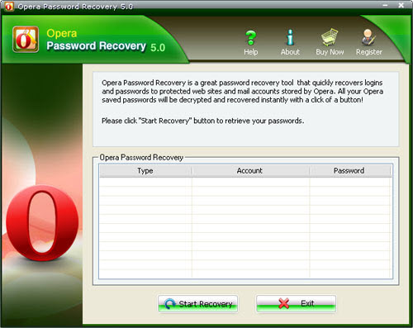
Step2: Click on the "Start Recovery" button.
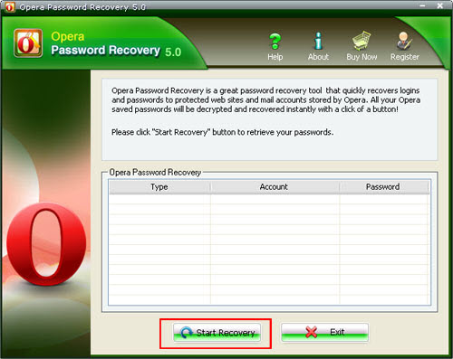
Step3: All the emails with Server Address, Login, Passwords, and Server Type are displayed in the box.
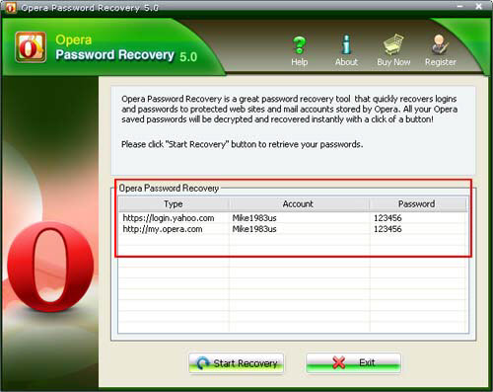

Know more about Opera Password Recovery Guide from:
http://www.recoverlostpassword.com/products/how_to_use_operapr.html

